ADITHYA R
192311369

24.Storage service using any Public Cloud Service Provider (Azure/GCP/AWS) and check the public accessibility of the stored file to demonstrate Storage as a Service.
AIM: To create a cloud storage service, upload a file, enable public access, and verify public accessibility to demonstrate Storage as a Service (STaaS) using Microsoft Azure.
Procedure:

STEP 1: Login to Azure Portal
- Open browser
- Go to https://portal.azure.com
- Login with Azure credentials

STEP 2: Create Resource Group
- Search Resource Groups
- Click Create
- Enter:
  - Resource Group Name: Storage-Service-RG
  - Region: Central India (or nearest)
- Click Review + Create → Create

STEP 3: Create Storage Account
- Click Create a Resource
- Search Storage Account
- Click Create
Enter details:
- Resource Group: Storage-Service-RG
- Storage Account Name: storagedemo2026 (must be globally unique)
- Region: Same as Resource Group
- Performance: Standard
- Redundancy: Locally Redundant Storage (LRS)
Click Review + Create → Create
⏳ Wait until deployment completes.

STEP 4: Create Blob Container
- Open the Storage Account
- Click Containers
- Click + Container
- Enter:
  - Name: public-container
  - Public Access Level:
👉 Select Blob (anonymous read access for blobs only)
- Click Create

STEP 5: Upload File
- Open public-container
- Click Upload
- Select any file (e.g., sample.txt or image.jpg)
- Click Upload
File is now stored in Azure Cloud.

STEP 6: Check Public Accessibility
- Click the uploaded file
- Copy the Blob URL
It will look like:
https://storagedemo2026.blob.core.windows.net/public-container/sample.txt
- Open a new browser tab (without logging into Azure)
- Paste the URL
✅ If the file opens directly → Public access is enabled successfully.

VERIFICATION TEST
To confirm public accessibility:
- Open the URL in Incognito Mode
- Or open it on another device
If file is accessible without login → Storage as a Service is demonstrated.

ARCHITECTURE
User → Public URL → Azure Blob Storage → Azure Data Center
Azure manages:
- Physical disks
- Replication
- Security
- Scaling
User manages:
- Data
- Access settings

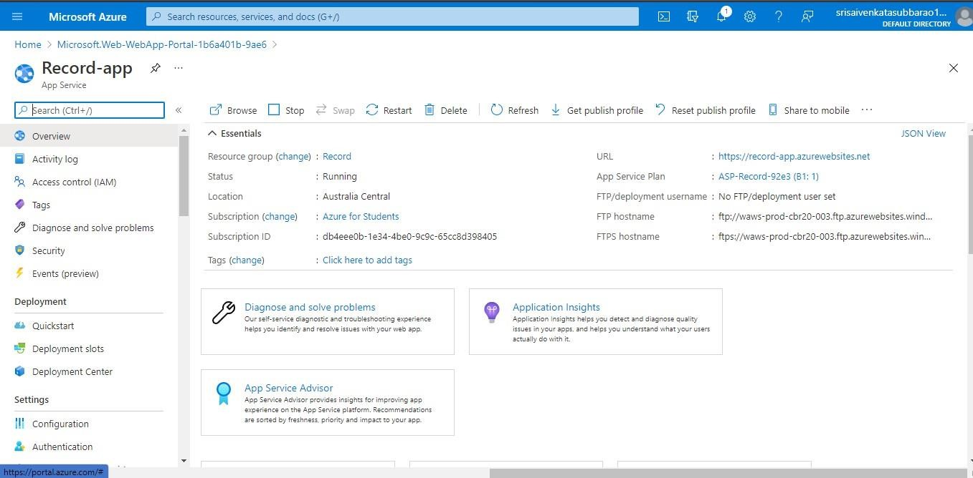

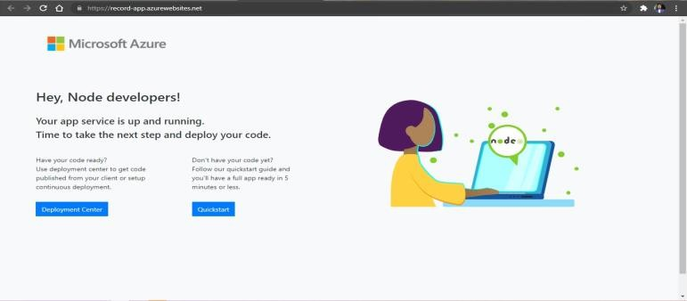

RESULT: The Azure Storage Account was successfully created.
A Blob container with public access was configured.
The uploaded file was accessed publicly via URL without authentication.
Thus, Storage as a Service was successfully demonstrated using Microsoft Azure.

